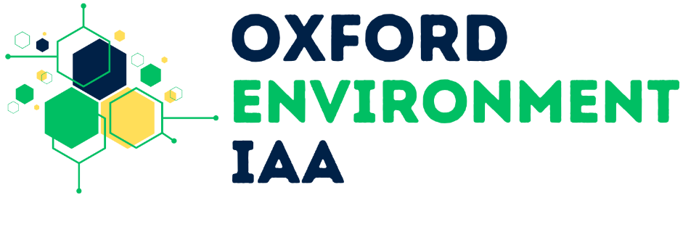
Environment Impact Acceleration Account

Comms pack

This pack contains content and messaging to promote the new Environment Impact Acceleration Account which is now open for applications from all University divisions.
Please help to promote this novel opportunity as widely as possible through your channels and networks.
Contents
Background 1
Audience 1
Newsletter / bulletin messaging 1
Internal audiences (short) 1
Internal audiences (long) 2
Social media messaging 3
Bluesky 3
LinkedIn 3
Graphics 4

Background
A new opportunity for researchers who are undertaking environment-related research across any disciplinary area has now been launched.

The Environment IAA is open to University of Oxford researchers in any disciplinary area. The scheme is designed to accelerate the impact of environmental research beyond academia, and funding will support a portfolio of activities at different stages of impact development through three complementary streams, with a rolling submission with three deadlines.

Audience
This new fund is aimed at University of Oxford researchers undertaking environment-related research from any disciplinary area who want to accelerate the impact of their research beyond academia.

Newsletter / bulletin messaging

Internal audiences (short)

New Environment Impact Acceleration Account – now open for applications

A new opportunity for researchers who are undertaking environment-related research across any disciplinary area has now been launched.

The Environment IAA is open to University of Oxford researchers in any disciplinary area. The scheme is designed to accelerate the impact of environmental research beyond academia, and funding will support a portfolio of activities at different stages of impact development through three complementary streams.

Applications are now open, and can be submitted on a rolling basis, with the first of three deadlines on Wednesday 30 September 2026.

Full guidance for the application is available on SharePoint (requires SSO)

Internal audiences (long)

New Environment Impact Acceleration Account – now open for applications

A new opportunity for researchers who are undertaking environment-related research across any disciplinary area has now been launched.

The Environmental Impact Acceleration Account (Environment IAA) will maximise the impact of Oxford’s environmental sciences research beyond academia by funding direct costs of knowledge exchange, translation, and commercialisation. It will support research projects and collaborations in driving policy change, developing new licensing and spin-outs, and more generally in driving sustainable economic growth across the region, nations and globally.

The Environment IAA is open to University of Oxford researchers in any disciplinary area. Supported through the University’s Strategic Innovation Fund, the scheme is designed to accelerate the impact of environmental research beyond academia. With local support for applicants from your divisional office, funding will support a portfolio of activities at different stages of impact development through three complementary streams:

Stream 1: Kick-starting Impact Award (up to £10k)
Small-scale activities to initiate or strengthen engagement and collaboration, including meetings, workshops, events, and early-stage translation activities.

Stream 2: Knowledge Exchange Partnerships (up to £25k)
Collaborative projects and secondments that build partnerships between researchers and external organisations, including industry, government, policy, and community partners.

Stream 3: Impact Acceleration Awards (Up to £60k)
Larger-scale projects focused on impact delivery, innovation, technology or toolkit development, prototyping, and translation activities that accelerate the application and uptake of research.

Applications are now open, and can be submitted on a rolling basis, with the following 3 deadlines:

1) Wednesday 30 September 2026, 5pm

2) Wednesday 13 January 2027, 5pm

3) Wednesday 12 May 2027, 5pm

The earliest start date for projects under this fund is 10 weeks after the call deadline. Projects can run for up to 12 months.

Full guidance for the application is available on SharePoint (requires SSO)

Social media messaging

Bluesky

The new Environment IAA is OPEN to applications from researchers undertaking environment-related research across ALL disciplines! 🌱 🔎 🌍
This new opportunity will maximise the impact of Oxford’s environmental sciences research beyond academia.
Find out more: (www.socsci.ox.ac.uk/articles/new-environment-iaa-boost-impact-environmental-research)
[NB Remove hyperlink in post after image box appears]

LinkedIn
🆕 The Environment IAA is now OPEN to applications! 🌱 🔎 🌍

If you are a University of Oxford researcher undertaking environment-related research across ALL disciplines, this is for you.

The new Environment IAA is devised to maximise the impact of Oxford’s environmental sciences research beyond academia by funding direct costs of knowledge exchange, translation, and commercialisation. It will support a portfolio of activities at different stages through three complementary streams, from kick-starting to larger scale projects.

➡️ Find out more about eligibility and deadlines: https://lnkd.in/ea-hfHa2

Graphics
