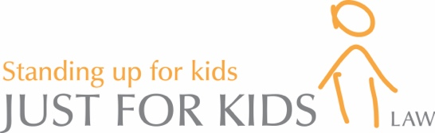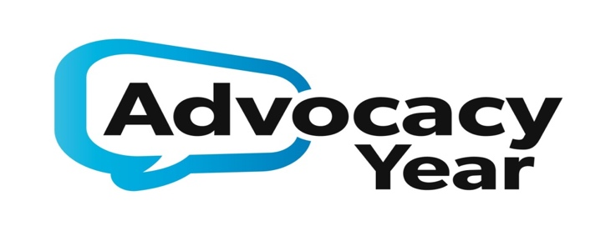

Trainee Youth Advocate – Recruitment Information

Below we have included key information about Just for Kids Law, Advocacy Year and the Trainee role within the charity. Please read this along with the role description and person specification and explore our website (www.justforkidslaw.org) to learn more about our work before applying.

About Just for Kids Law
Just for Kids Law (registered charity number 1121638) delivers client-led holistic representation and support to under-supported and often isolated children and young people from crisis to stability and onwards into independence in London. We do this through our innovative youth advocacy, specialist legal representation, and youth opportunities programme. We also drive systemic change through strategic litigation, policy reform, campaigning and our rights-based and youth led service model. We aim to be the UK’s leading experts in youth justice law, sharing our knowledge, expertise and model across the UK and beyond. In August 2015, the Children’s Rights Alliance England (CRAE) merged into Just for Kids Law, giving the organisation a national and international presence and network.

As a result of all our work, we were awarded a Halsbury Legal Award for Law in the Community. We also were awarded the status of Centre of Excellence by the London Legal Support Trust who described us as ‘an impressive and impressively run organization. It has a very clear focus on the needs of its clients and seems to be constantly striving to find new and innovative ways to help them.’

How we deliver our award-winning services
We provide individualised packages of support to address the multiple and complex issues that our young people face and that prevent them fully engaging within society. We provide:
- independent youth advocacy for children and young people on a ‘needs-led’ basis to help represent and support their wishes and to provide access to positive activities;
- legal representation in education and community care cases to ensure children receive education, housing, social services support and any other support to which they are legally entitled;
- specialist legal representation to children caught up in the criminal justice system;
- strategic litigation where we challenge the current youth justice system by undertaking cases that have wide-reaching impact for all young people;
- a Youth Opportunities Project to support young people into education, employment or training;
- an Ambassador Project made up of young people who have been supported by JfK Law and now work with our staff to influence decisions and design their own community projects;
- in-house and external work experience opportunities for young people;
- policy and lobbying work where we advise policy groups, think-tanks and government departments as well as drafting and responding to existing reports;
- unique training courses using our young clients as trainers. Using the first-hand experience of young people, we train law students, criminal justice practitioners, magistrates and judges on how best to represent and interact with children in court.

All these programmes work together to offer young people an holistic and joined up approach to address multiple levels of need.

About the Advocacy Year Programme and the Trainee Youth Advocate Role

Advocacy Year – The Model
Loosely based on other professional graduate schemes, Advocacy Year recruits recent graduates, who may be considering legal or youth related careers, as trainee Youth Advocates.
JfKL provides a unique advocacy service that works with young people on their instruction and at their pace, designing an individual package of support that covers all areas of their needs. Advocates listen to the young people’s wishes, make sure their voices are heard and facilitate a path from crisis to stability.
Trainee Youth Advocates will work in the community supervised by our current youth advocates. This will enable us to manifestly increase the support available to young people while ensuring the values and ethos of our holistic support model are maintained.
Sometimes the Trainee Youth Advocate will work alongside our specialist lawyers who:
- Help excluded children back into education and ensure children who have special educational needs (SEN) are adequately supported in school;
- Ensure that children and young people are appropriately accommodated and are being given the financial and pastoral support to which they are entitled from local authorities;
- Provide legal assistance at the police station and Court;
- Provide legal advice and representation in criminal and quasi-criminal proceedings; and
- Provide legal support for immigration matters.

Specifically, Trainee Youth Advocates will:

- Complete an intensive training and immersion programme covering:
- Advocacy style;
- Child safeguarding;
- Legal knowledge in social welfare, education, youth justice and immigration; and
- An ongoing Leadership programme.
- Work in the community directly supporting young people in difficulty.
- Formally advocate for young people in legal and quasi legal proceedings such as Looked After Child reviews, Social Services assessments, school reintegration meetings, governor body meetings and school exclusion hearings.
- Be supervised by our team of in-house lawyers to ensure that young people are adequately supported across all their issues.
- Work alongside the Opportunities team to ensure young people are supported to explore education, training and employment opportunities

Benefits:
- Gain legal, advocacy, negotiation and client-care experience with an award winning legal charity
- Trained in a range of legal competencies and supervised by experienced lawyers
- Additional training provided by leading public law lawyers
- Monthly leadership programme
- Direct client work in disadvantaged communities with under-supported young people
- Post-Completion participants join Advocacy Year Graduate Alumnae to share knowledge and practice
- Opportunity to support next year’s Graduate cohort

Who are we looking to recruit?

We are an ambitious and highly successful award winning charity. Year on year we have been growing to ensure that we can reach out to under-supported young people within London.
Advocacy Year recruits recent graduates, who may be considering legal or youth related careers, as trainee Advocates. We are looking for graduates who are passionate about improving the lives of under-privileged young people, resilient, have good team working and organisation skills, and are prepared to look for creative solutions and opportunities that will enhance the prospects and opportunities for young people. We will also expect you to be computer literate with outstanding communication and listening skills.
Experience of working with children and young people is desirable and your ability to build rapport and a relationship of trust will be a key area of assessment for the role. We especially want to make sure that young people are involved in all aspects of this project, helping us to shape the project, not just receiving our help as clients.
Applying

Review the Role Description and Person Specification, and fill out an application form. Return your completed application form and self declaration form with the subject line “Advocacy Year Trainee Application” by email to info@justforkidslaw.org by the closing date specified below. CVs will not be accepted.

Sadly we will be unable to contact unsuccessful applicants or consider those applications which are submitted after the deadline. Any job offer is subject to DBS approval and satisfactory references. Candidates must be legally able to work in the UK.

Key dates:
- Closing dates for applications: Tuesday 2nd May, 9am
- Date of Interviews: Week commencing 15th May
- Start Date: Monday 4th September

Queries
If you have any queries about the role please email these to info@justforkidslaw.org or call our office on 020 3174 2279. We will endeavour to speak to you immediately but sometimes this is not possible and we will contact you back within 24 hours of your enquiry.

