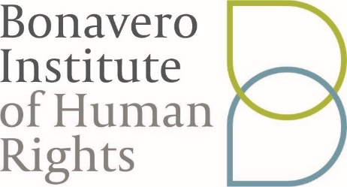

CALL FOR JUDGES:
BLACKSTONE HUMAN RIGHTS MOOT COURT COMPETITION 2019

The 2nd edition of the Blackstone
Human Rights Moot Court Competition 2019 is
scheduled to take place on 16th and
17th February at the Bonavero Institute
of Human Rights. This moot is organised in collaboration with the Institute, Oxford Lawyers Without Borders, and Mooting at Law.

The competition will act as a selection process to determine the team that will represent Oxford at the 11th Nelson Mandela World Human Rights Moot in Geneva. This competition is open to all undergraduate students in Law, as well as graduate students on the BCL and MLF. As one of the few moot court competitions that engages with international human rights law at Oxford, this is an excellent opportunity for students interested in this area to improve and showcase their advocacy skills, and engage in research in international and comparative human rights law. In addition to this, the Nelson Mandela World Human Rights Moot is one of the most prestigious mooting competitions in the world.

Read the competition case here and the rules.

In the past, the competition has been successfully run only with the incredible support of the Graduate human rights community at Oxford. In order to run this year's competition as well we are dependent on BCLs, MLFs, DPhils, and MPhils who are working on or are interested in international and comparative human rights law.

If you are able to volunteer your time to judge rounds on the 16th and/or 17th February 2019, please fill in this form by 3rd February 2019.

We hope that you will participate in fostering a community of human rights lawyers through oral advocacy training and research.

