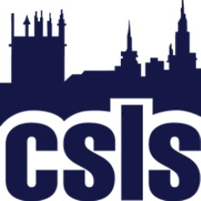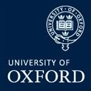

Methodology Masterclass
29th-30th July 2019, Oxford
Bursary Application Form

Places on the annual masterclass are free for ESRC funded students. The Journal of Law and Society and the Socio-Legal Studies Association is generously supporting a number of bursaries for the Oxford masterclass for other students. These will be allocated on a competitive basis.

If you are interested in applying for a bursary please fill in the information below and send your application to Linda Mulcahy, linda.mulcahy@csls.ox.ac.uk by 28th June 2019.

Name:
Email address:
Institution:
What year of PhD study are you in:
Where are you studying:
What are the names of your supervisors?:
Please provide a summary of your research topic in less than 250 words:
Please provide a summary in less than 250 words of what you think makes your research socio-legal:
Are you using empirical methods in your research? If so, which ones:
Please provide an explanation of why you think you would benefit from attending the workshop:
Are you a member of the Socio-Legal Studies Association?:

