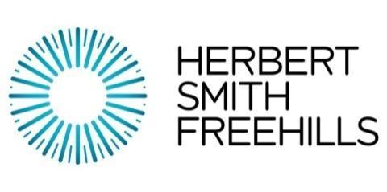
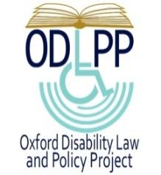
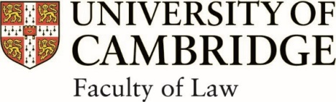
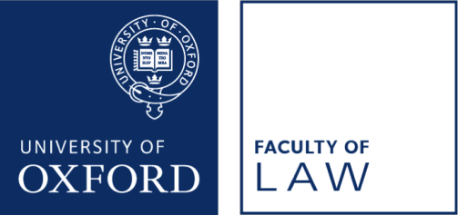

HERBERT SMITH FREEHILLS DISABILITY MOOTING CHAMPIONSHIP 2020: OXFORD v CAMBRIDGE

Programme - Saturday 14th November

2 pm Access Talk for Widening Participation and Pathways to Law
(45 minutes) Students

3.00 pm Introduction and Welcome
With Dr Marie Tidball (Senior Chair of the Organising Committee and Director of the Oxford Disability Law and Policy Project) and Sekela Ngamilo (Student Chair of the Organising Committee).

3.05 pm Grand Final
The Grand Final will be judged by Zoe Johnson QC (barrister, QEB Hollis Whiteman, and former Senior Treasury Counsel); Professor Jonathan Herring (Professor of Law and DM Wolfe-Clarendon Fellow in Law, Exeter College, Oxford); Daniel Hudson (Partner, Herbert Smith Freehills); and Dr Brian Sloan (College Lecturer & Fellow in Law, Robinson College, Cambridge).

4.30 pm Panel Discussion: The Right to Health: Has the Covid-19 pandemic
called into question the right to health equality and access to adequate healthcare for disabled people in the UK?

The panel will be chaired by Professor Tom Shakespeare FBA (Professor of Disability Research, London School of Hygiene and Tropical Medicine). It will comprise: Kush Kanodia (disabled BAME champion and Ambassador for Disability Rights UK); Lucy Watts MBE (Disability Rights advocate); Steve Broach (barrister, 39 Essex Chambers and member of the Equality and Human Rights Commission ‘A’ panel of counsel); and Baroness Campbell of Surbiton (Cross Bench Member of the House of Lords and long-term campaigner on disability, equality and human rights).

6 pm Announcement of the winners of the Mooting Championship

