Law and Legalism in Tibet

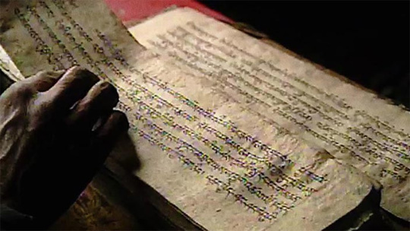

20th–21st January 2017

Haldane Room
Wolfson College, Oxford

Programme

Friday 20th January

9.30–10.00
Fernanda Pirie and Berthe Jansen: Welcome and Introduction

10.00–10.45
Lewis Doney
The Glorification of Imperial Law in Early Tibetan Buddhist Historiography

10.45–11.15
Coffee and Tea

11.15–12.00
David Pritzker
From bar mnga’ dar to bstan pa phyi dar: the Rhetoric of Law, Religion, the State, and Kingship in Early Tibetan Historiography

12.00–12.45
Leonard van der Kuijp
ʼBa’ ra ba Rgyal mtshan dpal bzang po (1310–1391) and His Quasi-Allegorical Decree of Religious Law (Chos khrims khyi ’ja’ sa)

12.45–14.00
Lunch

14.00–14.45
Fernanda Pirie
Which two laws? The concept of khrims gnyis in medieval Tibet

14.45–15.30
Max Oidtman
The Legal Vocabularies of the Khoshud Khanate

16.15–18.15
Visit to Pitt Rivers Museum and Reception

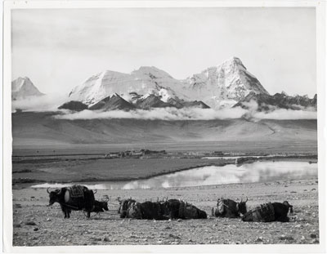

Saturday 20th January

9.30–10.15
Berthe Jansen
The Religious Ideology in Legal Texts from the Ganden Phodrang Era: a Preliminary Investigation

10.15–11.00
George Fitzherbet
Law and the Gesar Epic

11.00–11.30
Coffee and Tea

11.30–12.15
Dobis Tsering Gyal
The Bka’ Gtan Documents Issued by the Fifth Dalai Lama, Ngag Dbang Blo Bzang Rgya Mtsho, 1645–1680

12.15–13.00
Hanna Schneider
Contracts in Tibetan Private Law of the dGa’ ldan Pho brang Era

13.00–14.00
Lunch

14.00–14.45
Richard Whitecross
‘Law’ and the Zhabdrung ‘Estate’: the Tibetan Empire, Ralung, and the Concept of Law in Druk yul (1616–2016)

14.45–15.30
Peter Schwieger
Oath-Taking in Tibet’s Legal Tradition

15.30–16.00
Coffee and Tea

16.00–16.45
Charles Ramble
The Legal Inspiration of Tibetan Religion

16.45
General Discussion

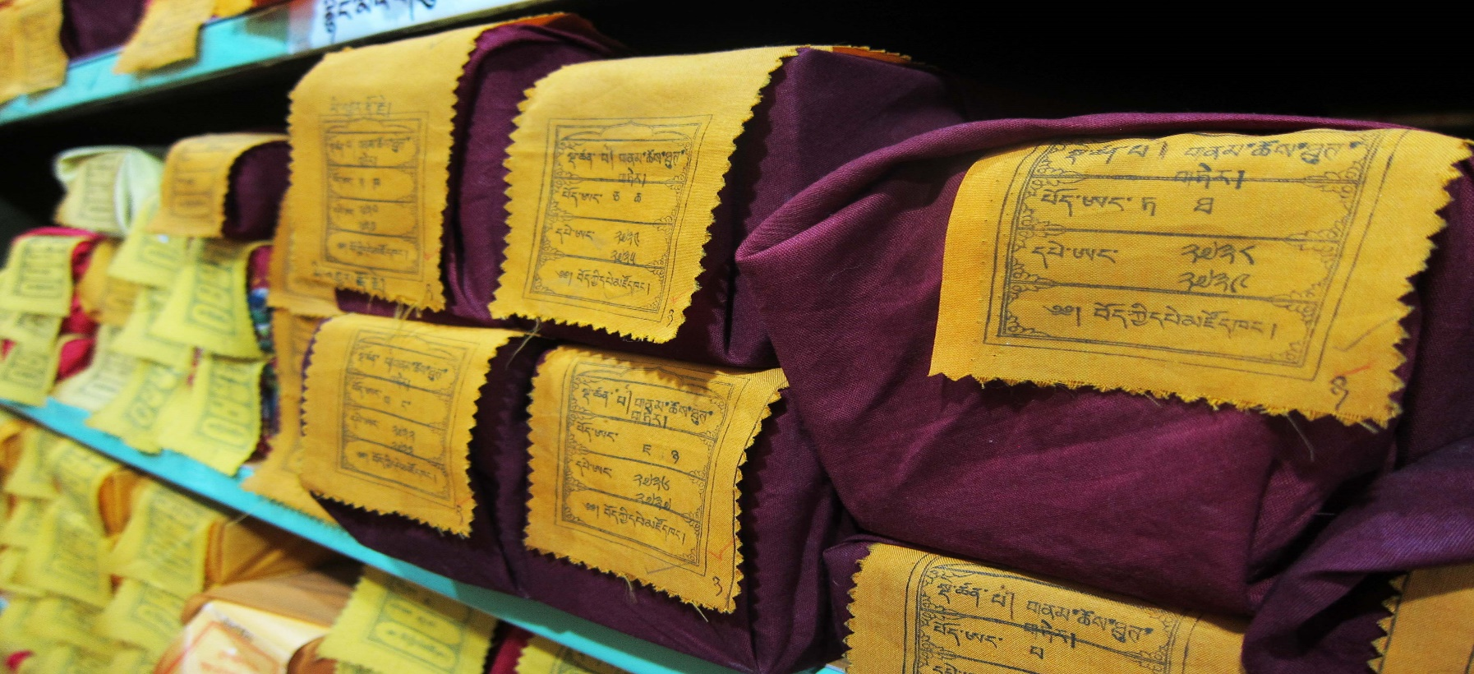
ABSTRACTS
(In alphabetical order of presenter)

The Glorification of Imperial Law in Early Tibetan Buddhist Historiography
Lewis Doney

Early Western visitors to Tibet portrayed the Tibetan imperial period as at first a time of wild lawlessness and disregard for the authority of emperor. Into these dark times was born Khri Srong lde brtsan (742–c.800), who valiantly attempted to tame his fellow Tibetans with the law of the Dharma. However, by inviting Padmasambhava, the Indic tantric master, to aid him in this endeavour, the emperor unwittingly welcomed into his home a viper, whose poison eventually weakened Tibetan society.
This depiction obviously contrasts starkly with the earliest historiographical depictions of these figures, yet the close relationship between imperial law and Buddhism and the positive yet ultimately human depiction of Khri Srong lde btsan shares some similarities to the views of these outsiders. In this presentation, I shall discuss the imperial self-presentation of Khri Srong lde brtsan, his post-imperial glorification in Buddhist historical works (including those attributed to lHa bla ma Ye shes ’od; c. 959–1040), and finally the eleventh-century dBa’ bzhed narrative core relating the introduction of Buddhism into Tibet. A detailed reading of these sources, once placed in this chronological order, uncovers first the increasing Buddhisisation of the image of this emperor and his proclamations on Tibetan law (khrims), and second how the perceived decline of the law and Buddhism during the “age of fragmentation” ultimately caused a crack in his perfect image. Unlike the perspective of early missionaries in Tibet, however, this was to the benefit of the depiction of
Padmasambhava.

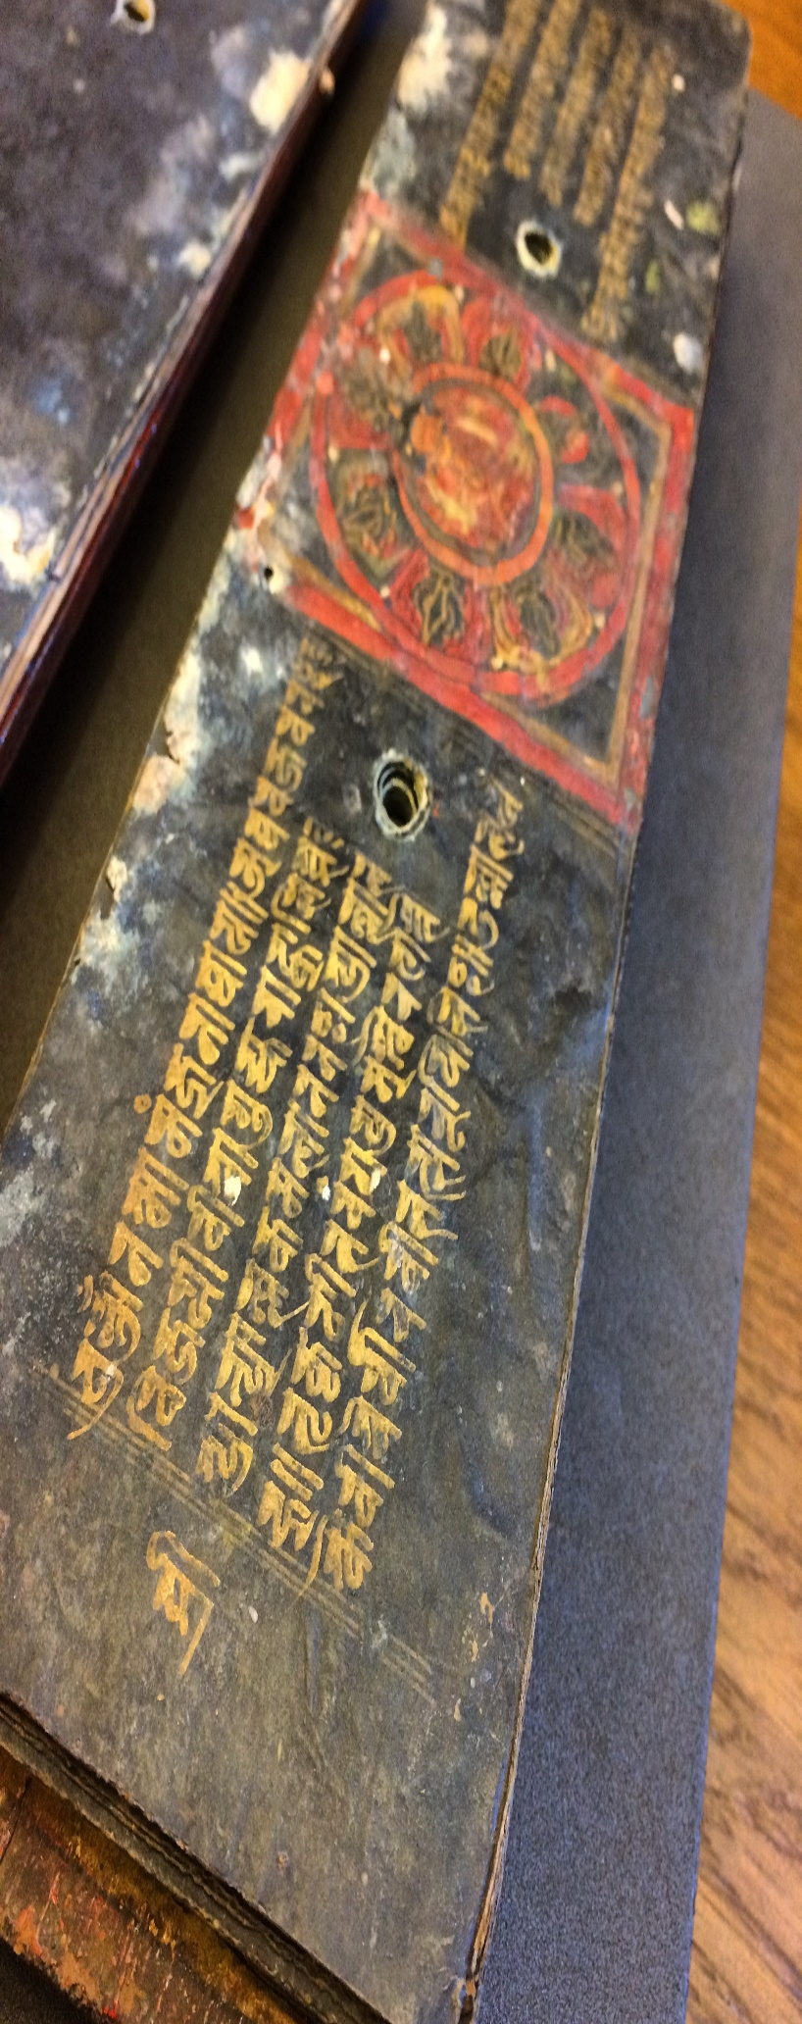

Law and the Gesar Epic
Solomon G. FitzHerbert

The references to Gesar in the Rlangs Po ti bse ru, the Zhal lce bco lnga and the Letters of Sum pa mkhan po Ye shes dpal ’byor, illustrate that the lore surrounding Gling Ge sar has long been considered a source of customary law in parts of the Tibetan world. This presentation will explore the theme of law one finds in the epic tradition. Not just in its many proverbs, but also in the models (dpe) the epic tradition provides for community assemblies, for the observation of status, for advocacy, and for conflict resolution and retribution. The presentation may also touch upon other areas that might also be described as having some kind of “legal” status, such as the distribution of wealth and grazing rights.

The Bka’ gtan Documents Issued by the Fifth Dalai Lama Ngag dbang Blo bzang rgya mtsho, 1645–1680
Dobis Tsering Gyal

This presentation is based on a collection of eight documents issued by the Fifth Dalai Lama in the Tibet Archives (Lhasa), which I have catalogued, measured, digitalized, and subjected to paper and textual criticism. My presentation tries to explain the terminologies of the Bka’ gtan documents and their characteristics of official documents, the legal concepts and aspects of the Bka’ gtans in the political system of the Dga’ ldan pho brang government. Combined with the autobiography of the Fifth Dalai Lama, Du ku la’i gos bzang, my presentation also examines and discusses some specific aristocratic families, monasteries, and high-ranking monk- intellectuals, which the Bka’ gtan documents discuss. These documents were mostly issued to protect property, such as land, water, houses, estates (gzhis ka) and others. They granted ownership of land, rights to taxes and law, and rights to conduct both peaceful and military affairs, to certain specific official institutions, both lay and monastic. These Bka’ gtan documents were usually issued by the successive chief executives, using different seals of authority, in the Dga’ ldan pho brang government.

The Religious Ideology in Legal Texts from the Ganden Phodrang Era: a Preliminary Investigation
Berthe Jansen

Monastic Buddhism influenced virtually every aspect of Tibetan society. Monks were responsible for most of the vast Tibetan literature. Through the texts they authored, then, monastic Buddhism exerted its influence on society. If monastic Buddhism influenced all facets of society, what was its influence on the corpus of legal texts, and on issues of legal theory within these texts? Focusing on a range of – largely unstudied – Tibetan legal texts, I will explore issues of intertextuality, linguistic influences, and the development of patterns, argumentation, and themes, allowing a theorization of Tibetan legal texts and their Buddhist contexts, and a positioning of Buddhist thinking within a broader socio-legal perspective. This paper is a preliminary investigation that focuses on the relationship between legal and religious texts in 17th -19th century Tibet, looking at the possible ways in which monastic language and concepts made their way into legal documents, and assesses their effects on Tibetan conceptualisations of law.

’Ba’ ra ba Rgyal mtshan dpal bzang po (1310-1391) and his Quasi-Allegoric Decree of Religious Law (Chos khrims kyi ’ja’ sa)
Leonard van der Kuijp

In fourteenth century Central Tibet, we begin to see further effects of the Mongol occupation, which began in 1240, on the Tibetan lexicon. Thus a scholar such as Dol po pa Shes rab rgyal mtshan (1292-1361) made use of the loanword ’ja’ sa (< Mon. ǰasaγ) in the titles of two of his shorter studies in the sense of "decree, governing rules [of]." The great 'Brug pa Bka' brgyud yogi and scholar ’Ba’ ra ba was the author of a monastic charter (bca’ khrims) as well as a very interesting quasi-allegoric work on basic Buddhist categories in which he uses the term in the very same way in its title. This is his Chos khrims kyi ’ja’ sa, which he probably composed tongue-in-cheek. We can assume that he had some fun writing it, for it is not always that religious texts contain such blatantly secular imagery as “the three poisonous conflicting emotions, the cause of the ten unwholesome actions]” for taxes (khral), etc.

The Legal Vocabularies of the Khoshud Khanate
Max Oidtman

The unification of Tibet, Kökenuur, Kham, and parts of Western Mongolia by the Khoshud Güüshi Khan in the 1630s through the 1640s is justly appreciated as a pivotal period in Tibetan history. Güüshi Khan emphatically brought the civil wars of Central Tibet to a conclusion and laid the foundation for the near monopolization of both religious and temporal administration by the Fifth Dalai Lama and the Geluk church. Subsequent Geluk hierarchs also celebrated the Khan for having promulgated a new legal code of 15 laws based on the Pakmodru Code of the 1300s. Or so we’ve been told. But what was the legal culture of the Khoshud Khanate from the 1640s through 1720? To what degree was it shaped by the conversion of the Khoshud to the Geluk teachings? How did it influence subsequent codes or legal culture? This paper will address these questions by examining several newly available archival sources from the era of the Khoshud Khanate in Kökenuur. The first is a set of bilingual (Oirat and Tibetan) edicts issued by Güüshi Khan and his descendants to Geluk hierarchs and other authorities in Kökenuur. The second is the “Code of the Kökenuur Oirat Confederation,” promulgated by Erdeni Dalai Hong Taiji, a son of Güüshi Khan in the Oirat language in 1685.

Which Two Laws? The Concept of Khrims gnyis in Medieval Tibet
Fernanda Pirie

A legal treatise entitled the Khrims gnyis lta ba’i me long (Mirror of the Two Laws) was created at the end of the fourteenth century. It seems to have laid the foundations for the zhal lce texts of later periods. But what were the khrims gnyis?
The treatise, itself, refers to chos khrims and rgyal khrims (religious and royal laws). These concepts are familiar from the long tradition of historical writing, which goes back to at least the eleventh century. Here they are sometimes likened to the silken knot and the golden yoke, but what exactly did they mean? Were they rules for monastics and laity, respectively, or did they refer to the moral rules of the ten virtues and practical rules for punishment? Meanwhile, in certain documents of the Yuan period the concept of rgyal khrims was used to refer to imperial authority. It has been suggested that the phrase khrims gnyis might be associated with the concepts of tshul gnyis and lugs gnyis, which emerged around the same time. Then again, in the Khrims gnyis treatise, itself, the application of the royal law is explained in terms of mediation practices.
In this presentation I will try to make sense of these varied meanings and thereby to shed some light on the question of what Tibetans understood by their concepts of law. I will suggest that in the relevant texts we can also see writers working out what it meant for Tibet to be a Buddhist polity.

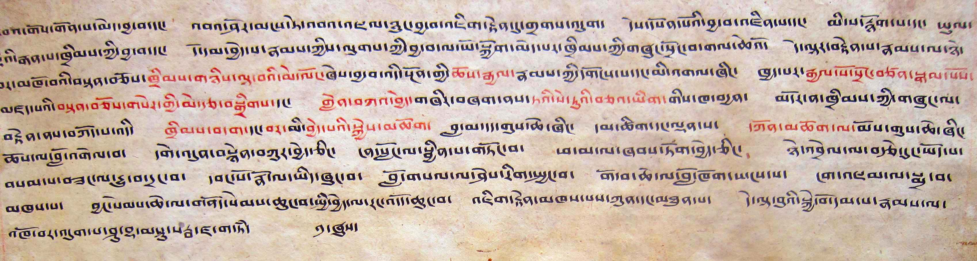

From Bar mnga’ dar to bsTan pa phyi dar: the Rhetoric of Law, Religion, the State, and Kingship in Early Tibetan Historiography
David Pritzker

The end of sPu rgyal dynasty and the beginning of the kingdom of sTod mNga’ ris is symbolically embodied in the escape of sKyid lde Nyi ma mgon from the maelstrom of collapse in Central Tibet. As the bridge between old and new, sKyid lde carries the proverbial helmet (dbu mog) of the sPu rgyal btsan po towards the Highlands of West Tibet. The Tholing Manuscript narrates the history of West Tibet, beginning with bKra shis mgon – the middle son of sKyil lding (Nyi ma mgon) –reestablishing the royal tradition (rgyal lugs) of the sPu rgyal in sTod mNga’ ris.
Because the yig btsang and sgo srid – words not easily translated – of the sPu rgyal are described here as extraordinarily unique, allowing their inheritors to “properly” rule the “polity” (chab srid), these terms must be analysed. What were the special “credentials(?)” (yig tshang) and “political methods(?)” (sgo srid) that allowed the heirs of the sPu rgyal to govern the polity so well? What was the relationship between these and how did the structure of the royal court in West Tibet emulate their predecessors?
This paper will explore these questions through a close philological analysis of key terms that mantle the relationship between kingship and law on the one hand, and religion and politics on the other. With the aid of early Tibetan historiography dealing with the interaction religion (chos) and the state (srid), we might better witness the ways in which specific terms and shifts in their rhetoric help to delineate the social-political and social-religious boundaries. By outlining these rhetorical contours I will show how early narratives negotiate kingship during this formative period in Tibetan history and how they can inform us of certain political structures, lost in the whitewash of dominant monastic histories.
The Legal Inspiration of Tibetan Religion
Charles Ramble

Tibetan legal treatises and institutions conventionally emphasise their debt to Buddhism, deriving their legitimacy from Buddhist rulers and religious principles. In spite of Dieter Schuh’s demonstration (1984) to the contrary, a number of more recent studies in both Tibetan and in European languages continue to subscribe to this pious vision. The fundamentally secular nature of Tibetan law should not, however, cause us to overlook the existence of a profound and intimate connection between Tibetan religious and legal traditions. The best-known Tibetan law codes may have been treated as literary models of an ideal hierarchical society rather than manuals of prescribed legal procedure, and it is likely that, in the past as at present, the vast majority of disputes were resolved by a skilled mediator who could negotiate a level of compensation that was acceptable to both the accuser and the accused. Rituals of the indigenous Tibetan religion typically feature a myth that legitimises the performance and ensures its efficacy. These myths are structured around three main agents: an offender who may be either human or divine; a divinity who has been offended; and a priest, who persuades the latter to accept a modest recompense for his injury and the former to pay it, thereby restoring harmony in the world. The evidence of these texts and rituals suggests that Tibetan religion was based on a legalistic vision of the cosmos that was extended beyond the confines of human society into the natural and praeternatural domains.

Contracts in Tibetan Private Law of the dGa’ ldan Pho brang Era
Hanna Schneider

How were the laws in Tibet between the 18th and the 20th century, and partly outside of the central administrative seat of Lhasa, instituted and how were the provinces of dBus and gTsang governed at the local level? How were private disputes negotiated across thenormal channels and lines of authority? What was the bKa’ shag‘s (the Central Tibetan Administration‘s council of ministers‘) role as appellate court? Are the terms and concepts of contract law and private law applicable to the Tibetan legal system? My take is “yes“! This presentation will also investigate the different forms of contracts in Tibetan private law, especially the role of gan rgya (obligation contracts), dpyad mtshams khra ma (deeds of arrangement), and ’dum khra (arbitration and settlement documents), which also occupy a special place within Tibetan diplomatics. My contribution seeks to outline the importance of Tibetan private law within the whole Tibetan legal system of the abovementioned era, within the framework of Tibetan diplomatics and comparative law studies.\

Oath Taking in Tibet’s Legal Tradition
Peter Schwieger

The paper circles around four interlaced questions: What made Tibetans believe in the potency of oath? What was the function of oaths in Tibetan legal proceedings? Why was the unchallenged authority and expertise of the clergy indispensable for the function of oaths in Tibet’s legal proceedings? And who was responsible for offering loopholes to enable the escape from the consequences of a broken oath? The paper is mainly based on Tibetan law texts and legal documents.

“Law” and the Zhabdrung’s “Estate”: The Tibetan Empire, Ralung and the Concept of Law in Druk Yul 1616 – 2016
Richard W. Whitecross

The paper argues that the role and meaning of law and its presence need to be seen as unfolding and ever changing rather than as monolithic. Brown (2015) encourages us to consider the different worldviews expressed in different periods. So what did “law” mean in Bhutan? This paper focuses on the emergence of “state” law and its role in shaping the administration and governance of the emerging Drukpa state. It begins with a discussion of the importance and influence of Ralung and the models of governance and laws known to the Zhabdrung, Ngawang Namgyal before his flight to western Bhutan in 1616. Drawing from a range of written sources, the paper considers the process of establishing the “chos gzhi” or “religious estate” by the Zhabdrung and his successors. As the Drukpa state was consolidated during the seventeenth and early eighteenth centuries, the paper considers the development of the Drukpa legal system and its close interrelationship with the Drukpa state. These sources draw on Tibetan sources and Tibet’s imperial past and in particular on Srong brtsan sGam po as the giver of laws. The establishment of the monarchy in 1907 maintained aspects of the dual system whilst turning to other sources of law beyond Tibet, notably British Colonial India. The paper concludes by examining “law” in its contemporary context and the changes in the role and meaning of law traced over four centuries.

